Steps to set up git and a github repository

- Create a folder GItHubRepos for your github repositories. I find it best to not put in my one drive folders. I find on windows it is best to put in your C drive. On Mac I put it in my documents but not in OneDrive.

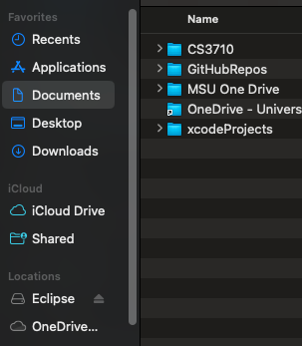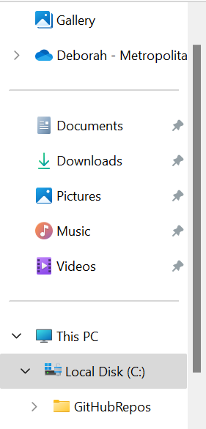
Put here
Windows
Mac
Do not put here
Do not put here
Put here

- Download GitHub Desktop to connect your git code version to the GitHub server. This allows you to version locally on your computer and push to the Github cloud server.
- Create a free GitHub account if you do not have one. Select Join for free. Follow the prompts to create your personal account or organization. You may want to use your personal email rather than school email. You will need to verify your email.
- After verifying your email you can set up your account. There may be some questions to answer. Do not worry if you are not sure what they are asking. You can just answer what is required.
- Open github desktop, click Add, Select Add Existing Repository
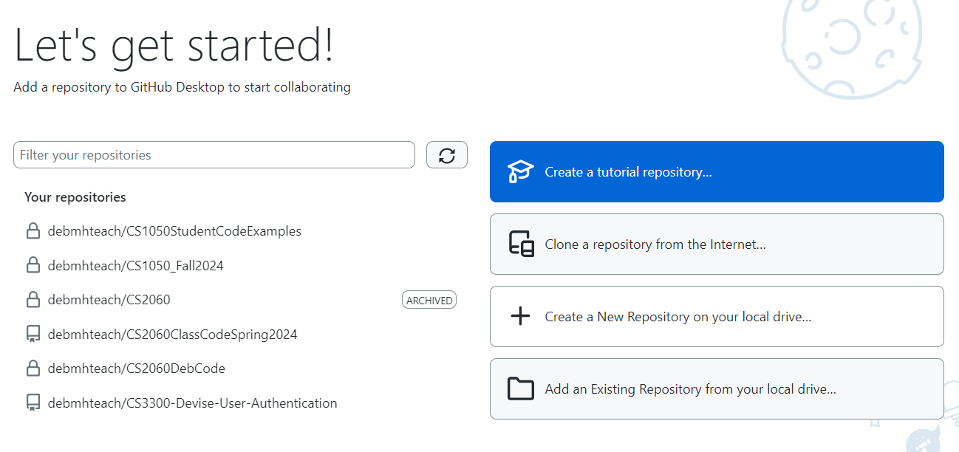

- Fill information to create a repository
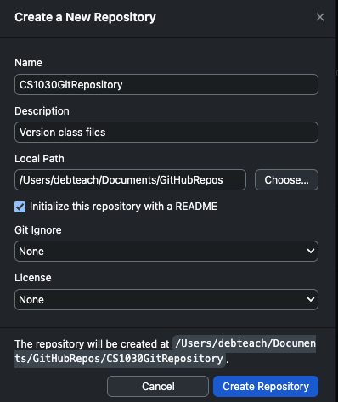

Name of repository Using course name and semester
Choose GitHubRepos folder you created above on your localo computer
Check
Select Java
- Read the information about publishing you repository and click Publish Repository
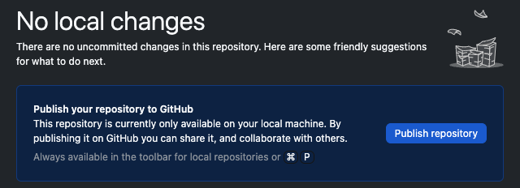

- Keep this code private so you are not sharing your solutions with others for this class and Publish Repository.
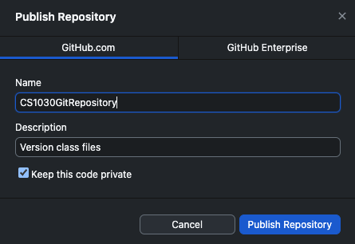

- You will manage your files in this class with the Github desktop so you can understand the different git commands. Show your files locally on your machine.
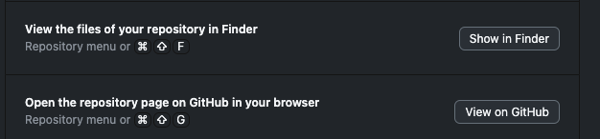

Go to files stored locally on your computer
Go to files stored on github cloud server

When you show your files in the finder you will see the following. This is keeping track of your versions. If you do not see the .git information you can reveal hidden files.
- Mac: To reveal hidden files in Finder, go to Go > Computer > Macintosh HD and press Shift + Command + . (period).
- Windows: View hidden files and folders in Windows - Microsoft Support

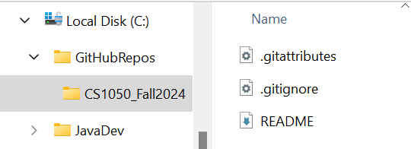

- Click View on Github to see the repository was pushed to your cloud GitHub server.
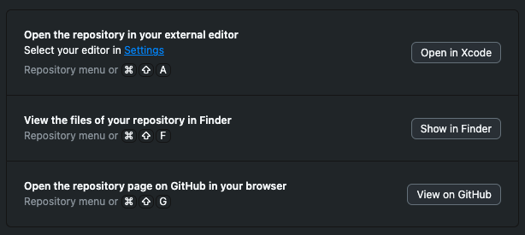

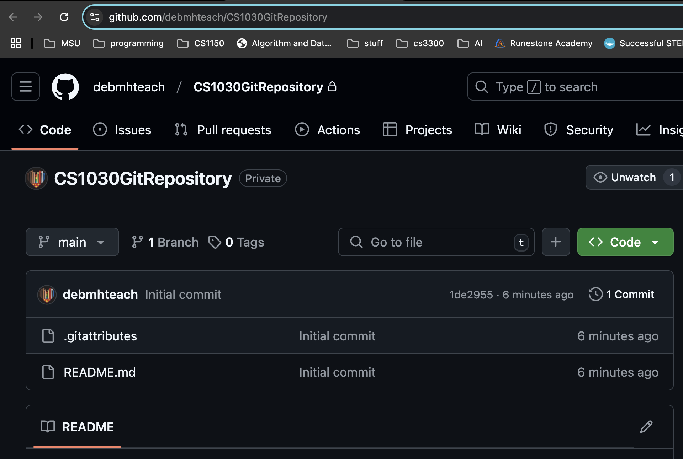
- Open the README.md file and click click to edit.
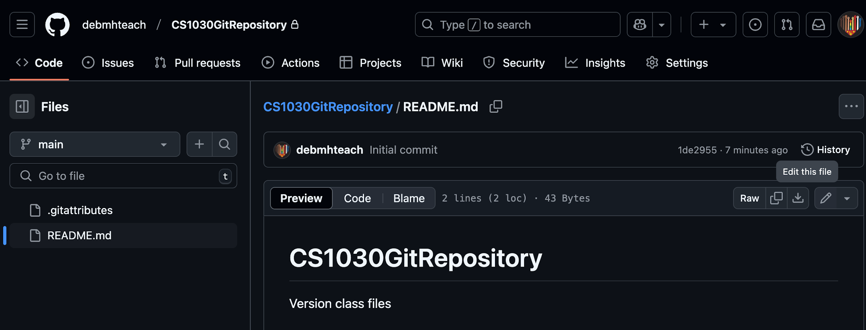

Click to edit file

- Add the following to the file: My edits will be versioned after committing changes. Then commit changes.
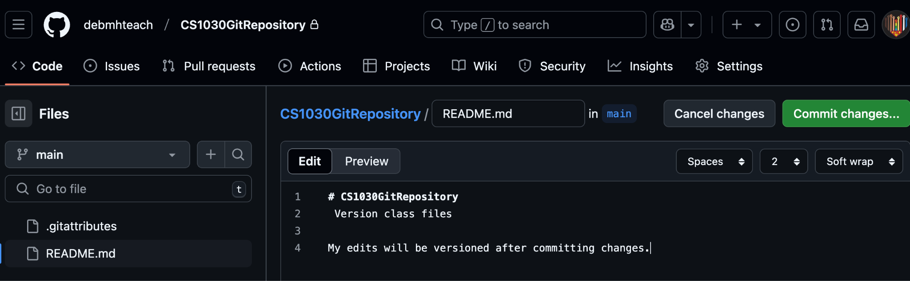

Click to commit changes. This means create a new version.

- Add descriptive comments of what changed. Put this message: test commit and versioning. Click commit changes.
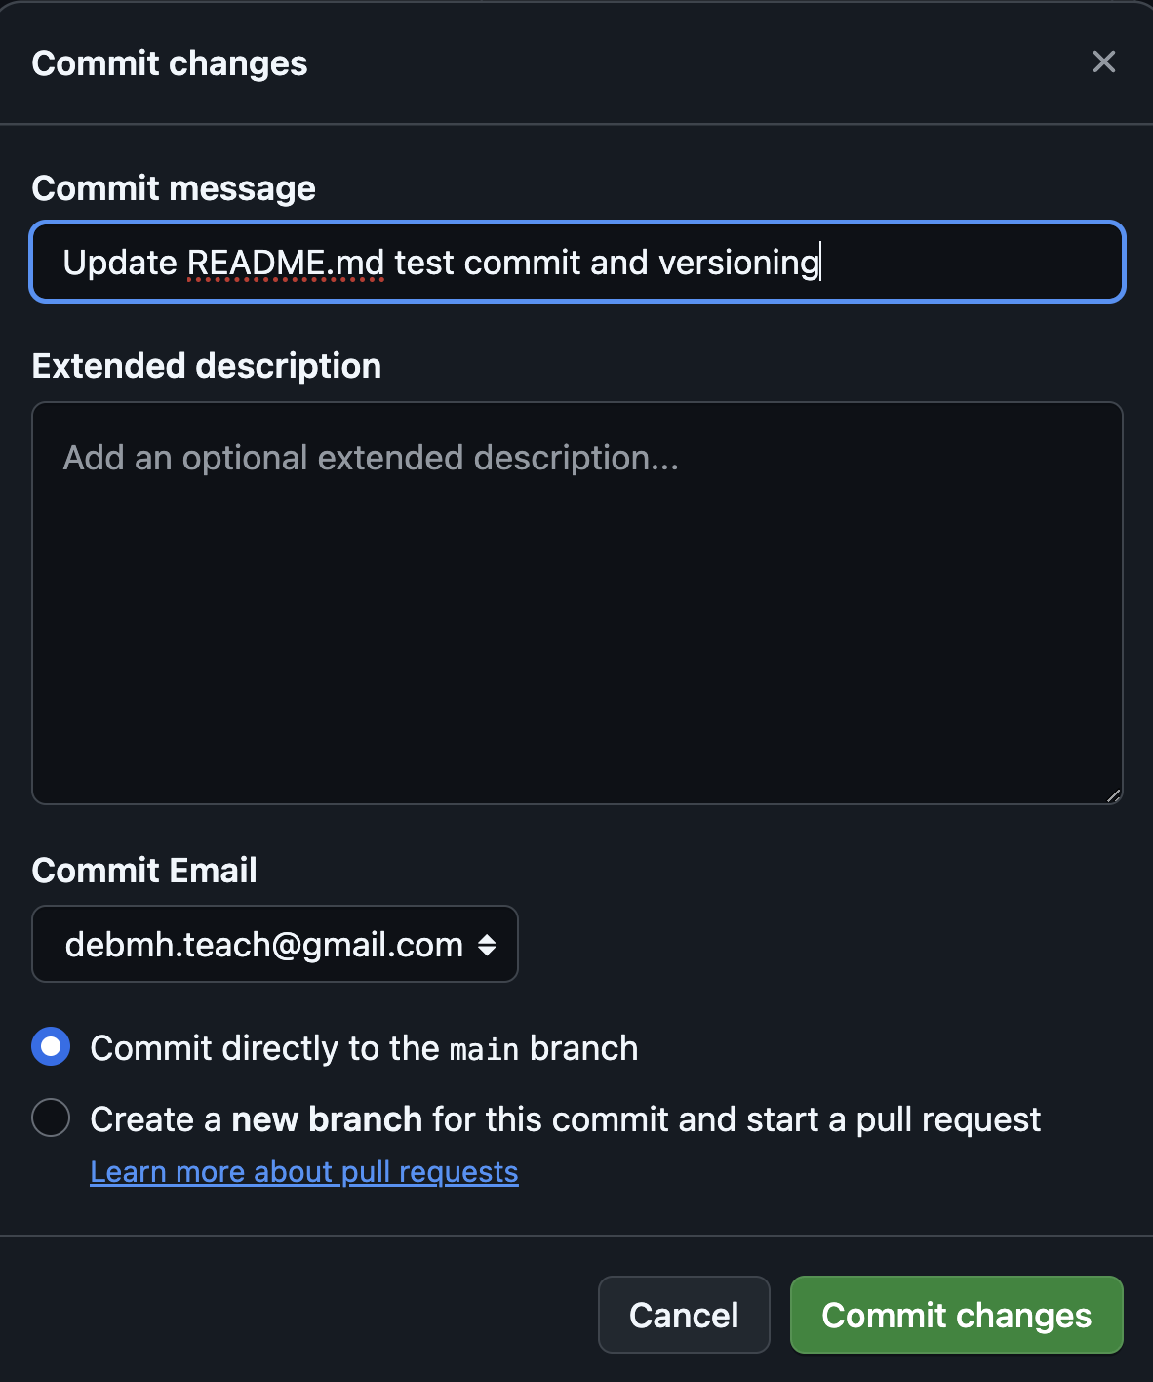

- Go to your repository on the github remote server to see the changed file and two versions.
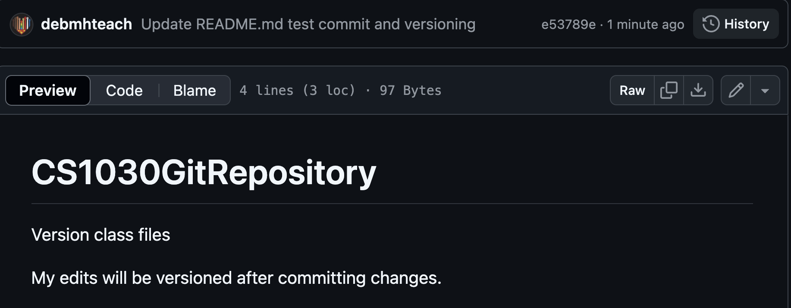

Click to see the versions

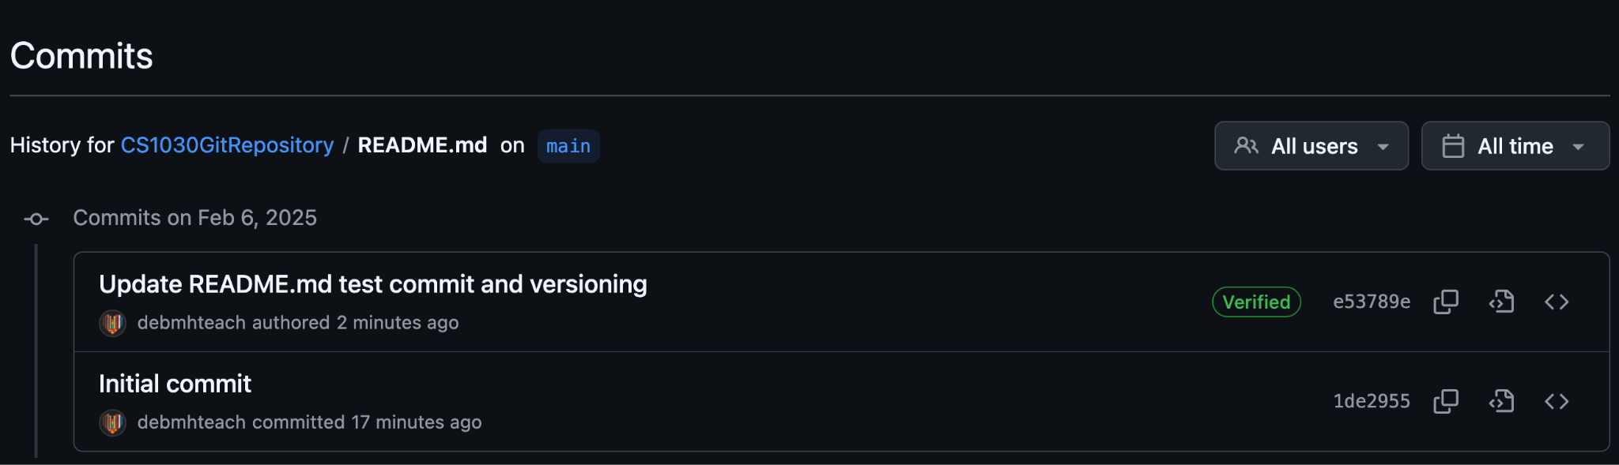

- Go back to your github desktop and you will need to pull origin to download the updated file to your local computer. Click Fetch in top right and then Pull Origin. What is pull doing?
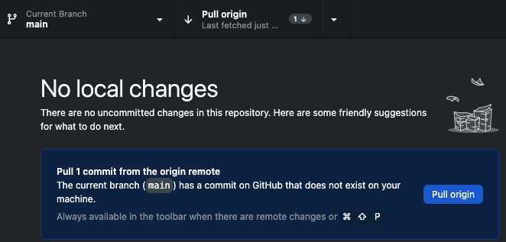
Fetch

- Go to your local repository by clicking show button


Go to files stored locally on your computer
- Open the README.md and make a change.
- Go back to your desktop and commit the changes. What is commit doing?
- Then push your changes. What is push doing?
- Click to view on github. Go look at the versions.
- Go back to your local folder CS1030GitRepository and add the following folders
  - TechDocs
  - Assignments
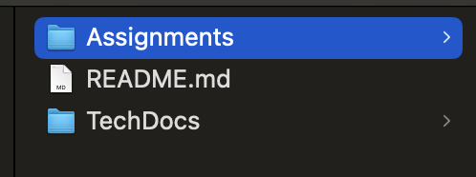

- Put your technical document in the tech docs folder
- Put your GE assignment in your assignments folder
- Put this document in your Techdocs folder
- Version the files in your repository on your computer and then move to the github cloud using github desktop.

Git and GitHub Resources
- Getting started with GitHub Desktop
- github docs
- About Git - GitHub Docs
- Cloning a repository
- Pushing commits to a remote repository
- Git Guides - git pull · GitHub

